**Assignment 2 (CLO2) 10 marks**

**Integrating Factor**

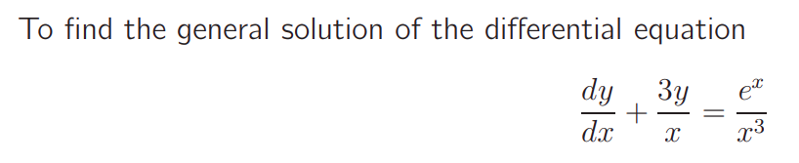

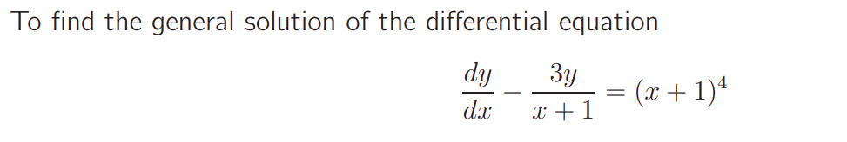

Solve the differential equation using the integrating factor: (dy/dx) – (3y/x+1) = (x+1)4

**Cauchy-Euler differential equation**

Solve: x2 y′′ − 6xy′ – 18y = 0

Solve the differential equation x2 y′′ − 7xy′ + 16y = 0 for x > 0.